**Blockchain-Enabled Federated Learning for Secure Healthcare Diagnostics**

**Anindya Sundar Maity1** [iD](https://orcid.org/0009-0005-4964-4362)**, Subhadeep Ghosh2** [iD](https://orcid.org/0009-0007-0355-8754)**, Milan Das3** [iD](https://orcid.org/0009-0007-0354-5718)**, Sreedeep Ghosh4** [iD](https://orcid.org/0009-0003-2252-5238)

Department of Computer Science Engineering (Artificial Intelligence & Machine Learning)

Email: [anindyamaity2004@gmail.com](mailto:anindyamaity2004@gmail.com), [subha3705@gmail.com](mailto:subha3705@gmail.com), [milandas4418@gmail.com](mailto:milandas4418@gmail.com), [sreedeepghosh2003@gmail.com](mailto:sreedeepghosh2003@gmail.com)

**Abstract.** In this paper, we introduce a novel system for multi-disease prediction in the field of health that uses a multi-layered approach of AI, blockchain, and federated machine learning. The federated learning aspect allows for better accuracy of predictions while at the same time protecting data integrity using role-based access on the blockchain. The architecture allows for a one-to-many propagation of data, and reversible and modular design to accommodate additional diseases to the system. We observe enhancements on performance, security, and real-world applicability when comparing our decentralized approach to a traditional system. Together, the use of cloud-blockchain federated learning technologies provides a new model for healthcare delivery that supports a developmental framework and the origins of safety.

**Keywords:** Blockchain, multi-disease prediction, federated learning, data security, role-based authentication, decentralized healthcare, scalability, predictive accuracy, real-world deployment, real-time tracking, adaptive healthcare.

1. **Introduction**

Artificial intelligence (AI) is reshaping the ways in which physicians diagnose, predict, and treat illness. By its capability to treat large sums of data, identify intricate patterns, and provide useful insight for clinical decision-making, AI instruments are enabling medical practices to be done with greater speed and accuracy. Nonetheless, artificial intelligence has yet to solve problems relating to data security, privacy, or unauthorized access to healthcare practice. As we progress into an acceptable level of comfort with and reliance on AI technologies, we can begin to consider applying stronger levels of security that can protect sensitive medical information whilst appropriately managing both confidentiality and integrity.

To manage these risks and improve prediction accuracy, researchers have suggested combining AI and blockchain technologies. Such an approach seeks to build off the pros of existing federated learning models and use blockchain to mitigate security vulnerabilities and assist in diagnostics. The blockchain provides a secure way to store medical information, providing the ability to create a tamper-proof method of preventing changes by an unauthorized party. The entire proposed framework includes mechanisms for allowing or restricting access to data, in order to ensure that only those with permission are able to access or modify a patient record.

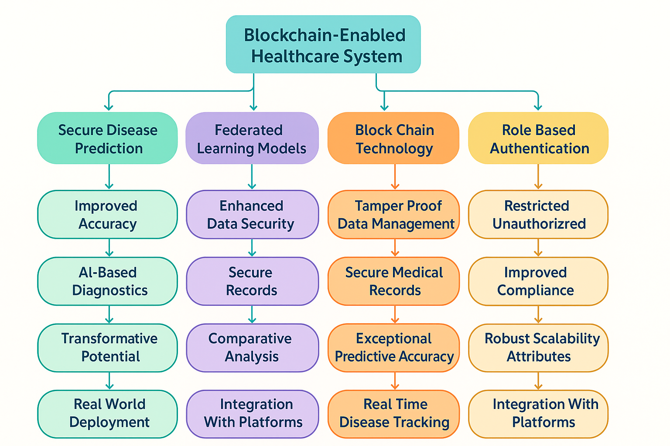

**Figure 1** Conceptual framework of Chain Learn Nexus

Up to this point, everything is based on a centralized system where all information is stored in a single location, which leaves it open to outside attacks and possible tampering. The very same vulnerabilities present a threat to patient confidentiality and the quality of healthcare functionality. Blockchain will address the management of medical records and healthcare data in a secure and decentralized way using an unchanging structure. When medical predictions can be orchestrated with diagnostics by AI, the predictions can be secured and the patients' data can be secure for all legitimate uses.

AI is increasingly becoming important in healthcare to help assure early detection of disease and treatment. Deep learning, in particular, is extremely powerful at processing medical images and electronic health records (EHRs). Being able to extract information for predicting medical diagnosis, AI has assisted healthcare in the development of treatment plans that will assist patients in better health outcomes.

Challenges to data security and data integrity continue to be serious obstacles. Current systems are reliant on as much information as possible to improve medical predictions, and storage policies are often not meeting privacy measures and regulations currently in place. The risk for data breaches and no assurance on unauthorized access only decreases patient trust and access while organizing to comply HIPAA (Health Insurance Portability and Accountability Act) or GDPR (General Data Protection Regulation) regulations. Utilizing blockchain, and combining with medical predictions, addresses all these issues as an organized measure to avoid it.

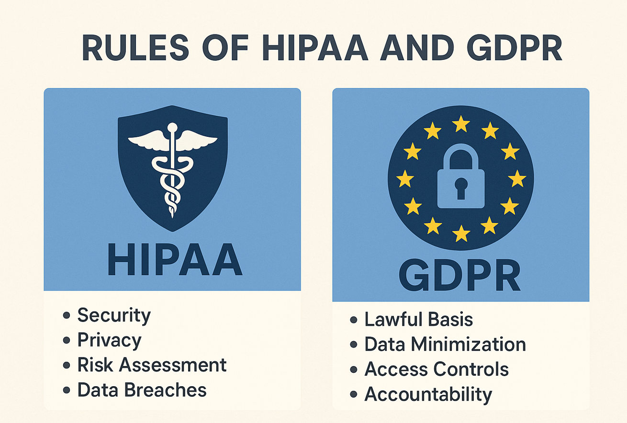

**Figure 2** HIPAA and GDPR Law

Blockchain technology is a new tool for safely managing medical data from a decentralized platform, and unalterable transaction log. Each medical record is stored as a block linked to a previous medical record, which creates the chain anti-corruption mechanism to limit altering the record. The blockchain itself allows only authorized individuals to have access to the patient data. Blockchain also uses smart contracts to provide secure protocols for utilizing the blockchain for compliance, security, and secure sharing of data between users. In addition, role-based authentication provides limits on who has access to patient data to accepted individuals, which enhances data security.

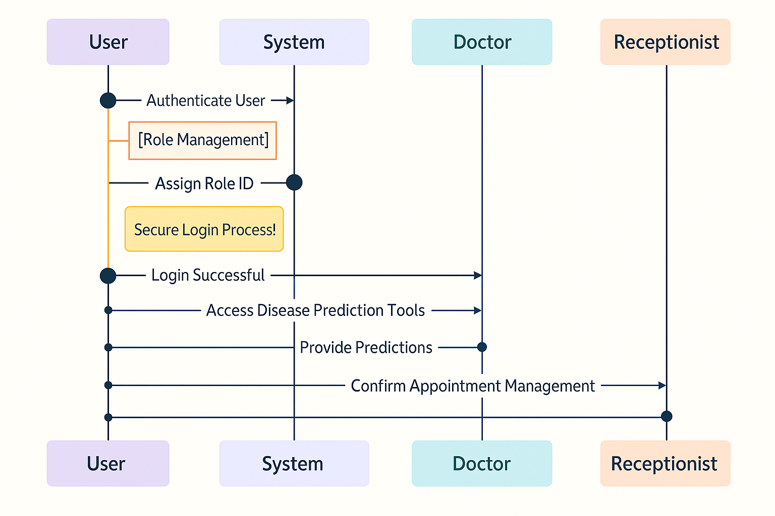

**Figure 3** Sequence Diagram

Most health systems use centralized data storage so data may be vulnerable to failure or attack; furthermore, the inability to share data between different locations leads to fragmented healthcare service delivery. A blockchain solution addresses these concerns by permitting transparent, decentralized, secure data management (medical records + artificial intelligence [AI] diagnostics). Blockchain technology increases efficiency in healthcare services and makes them more seamless. Research on the value of traditional health systems with and without blockchain concludes that there is a substantive difference by adding blockchain.

Here are some key advantages:

1. Data Security - ensures the immutability of the medical records.
2. Predictive Accuracy - uses data securely stored to improve prediction of disease.
3. Scalability and Interoperability - Health facilities that are non-centralized share data easily to improve the care of patients.
4. Access & Privacy - Only persons authorized access to patient information, thus enhancing privacy and security.
5. Regulatory Compliance – The transparent protocol for tracking each record via the blockchain may help the healthcare system be compliant with regulations and simplify audits.

Blockchain technology has the capacity to be scaled in large healthcare networks, and it is ready to evolve with the emergent future applications of tracking disease in real-time and for performing more intelligent diagnostics with AI. Blockchain-based platforms create better integration, faster disease detection, and better-informed decision-making for patients in healthcare services.

Additionally, the ecosystem supports new collaborative learning methods, increasing its capability to predict other diseases. Federated learning will permit medical data to reside within each Health Centre while ensuring privacy, but still support collective model training. In this learning model, the protocol heightens security to share data yet preserves patient confidentiality.

1. **Literature Review**

**2.1** Differential Privacy in Healthcare Diagnostic

Differential Privacy (DP) is a cutting-edge approach to protecting confidentiality in order to derive valuable insights from sensitive medical data. Artificial intelligence (AI) has been instrumental in redesigning healthcare diagnostics processes by improving process accuracy, improving treatment processes, assisting the patient with their treatment, and providing an opportunity for real-time predictions about dis-ease identification. However, patient privacy concerns and data protection issues remain abiding concerns. Typically, diagnostic systems rely on a centralized database. If those centralized databases are improperly accessed, they are vulnerable to data breaches. Differential privacy on the other hand learns from data without the ability to filter individual records. Machine learning (ML) and deep learning (DL) methods have displayed exceptional performance in the identification of dis-ease diagnosis, medical image analysis, and predictive modelling. A number of healthcare applications based on AI require access to large volumes of patient data using machine learning. This open access generates patient data privacy and miss-use concerns. The important commitment of differential privacy is that AI can infer useful patterns in medical records without disclosing personal and sensitive patient data. This involves the application of mathematical noise, so that individual contributions can be masked whilst still retaining mathematical correctness. Although differential privacy has potential benefits, especially given its proliferation through health care, there are challenges. The challenge of balancing privacy protection and the usefulness of the model is a challenge, as excessive noise reduces AI performance. Also, implementing differential privacy into existing healthcare systems requires technical expertise and computing resources. Regardless, combining differential privacy with blockchain technology presents a good solution for non-static data which relies on preserving data integrity and patient confidentiality. Because blockchain offers both decentralized records and immutable storage; it complements the privacy guarantees of AI-based healthcare diagnostics.

**2.2** Blockchain for Secure Management of Medical Data

Blockchain technology is a system of distributed ledger providing integrity, transparency, and security of data. In healthcare applications, blockchain solves pervasive problems such as data misconduct and unauthorized access to data, tampering with records, and issues of interoperability. Blockchain serves as a means to provide an immutable storage and verifiable storage system of medical data, that allows access by authorized individuals while maintaining data integrity. Healthcare solutions based on blockchain technology utilize smart contracts to autonomously verify medical records, allowing only verified users to view patient information. Smart contracts are automated functions that allow secure information sharing of data to and from insurance companies, hospitals, and patients without the need for middlemen, which also lowers administrative costs. Another distinct benefit of blockchain in the healthcare space is that it stores its information in a distributed manner, limiting the risk of a centralized point of failure. Centralized systems are often vulnerable to cyberattacks and data breaches. In today’s ever-evolving world, with blockchain, it is nearly impossible to execute an attack that could make unauthorized changes to the records, as they are stored on a peer-to-peer system. In addition, blockchain technology provides the ability for data interoperability as it provides a standard platform for healthcare providers to communicate and exchange medical records. Healthcare providers often work with different data formats, causing inefficiencies in the exchange of information! Blockchain solutions aggregate these records and create records that allow communication across various medical institutions.

**2.3** Federated Learning for Privacy-Preserving Healthcare AI

Federated Learning (FL) is an emerging machine learning paradigm for training AI models at multiple institutions simultaneously, without having to share any of their raw data. FL works particularly well for use cases in healthcare, where extreme privacy constraints are imposed on training data sources by law (i.e., HIPAA and GDPR). FL allows for the training of AI models across distributed nodes while still respecting patient privacy and using patient data during the learning process. Each hospital or clinic involved in training the model is training the model on its own data, and there is no sharing of sensitive patient data. Decentralized learning with FL is also conducive to blockchain technology, which further enhances data security and integrity.With the use of FL and blockchain technology, medical facilities can utilize non-sensitive patient data to realize real-time disease prediction and prevention without compromising patient privacy. In addition, FL helps to minimize AI model biases, as multiple datasets from different institutions are merged before modelling and prediction to develop generalized and thus, potentially more accurate population level predictive models.

**2.4** Role-Based Authentication and Access Control in Healthcare

Access control in healthcare is extremely important, particularly because healthcare organizations must ensure that individuals granted access to sensitive medical information are authorized. Credential verification (ex. password methods) are inherently unsafe and create access points for identity theft. A more secure form of logging in could include blockchain-based, role-based access control or authentication. EHRs can restrict access to medical records based on job roles of individuals (ex. Health personnel, administrators, and patients). This presents a secure method of ensuring access to medical records while maintaining communication systems among staff members while keeping medical records secure. For example:- Physicians have access to see and update patient records.- Patient's can view their medical history, but can't change information.- Hospital administrators can manage user permissions, but can't access personal health information. This form of authentication does not require a central authority or storage for passwords. Eliminating them as an instrument that can be hacked. By adding an extra layer of biometric authentication (ex fingerprint, OTP, facial recognition), further security can be attained. This gives a higher assurance that a person's identity is correctly identified, avoiding scenarios like identity theft or unauthorized access to medical claims.

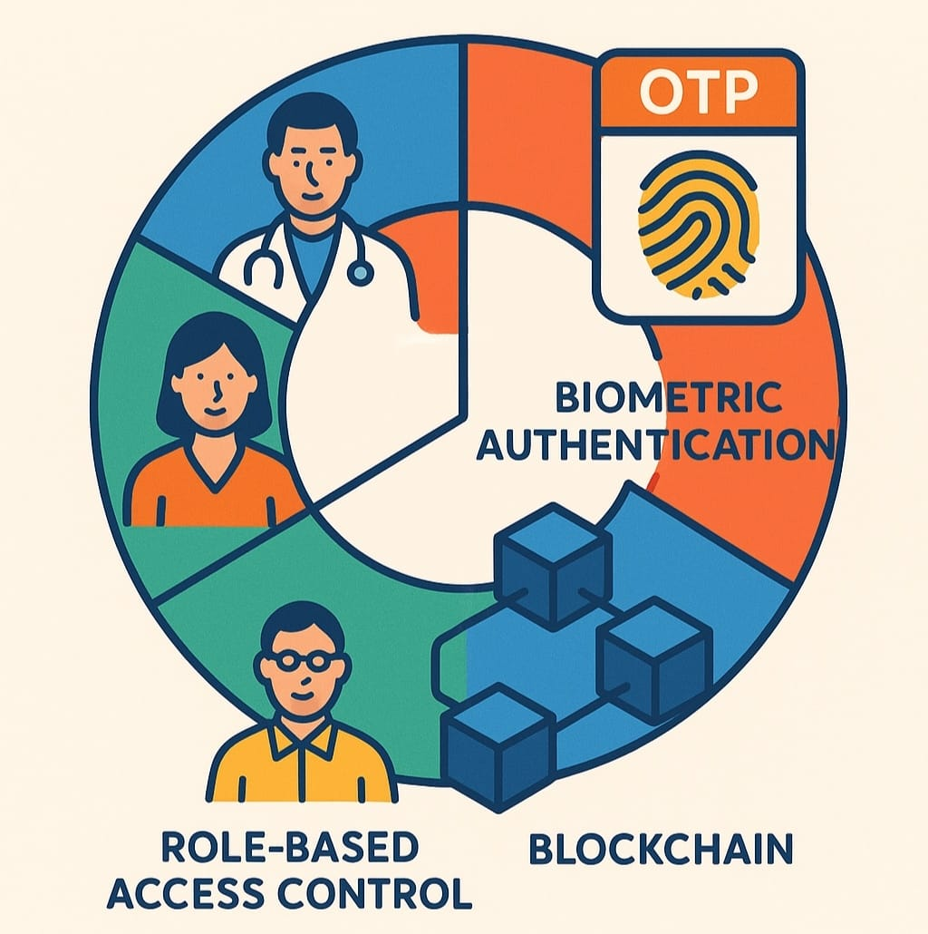

**Figure 3 Authentication and Access control**

Placing traditional healthcare systems beside blockchain systems shows clear advantages for blockchain. Blockchain systems establish an extremely secure and reliable backdrop.

**Table 1** Comparative Analysis: Traditional vs. Blockchain-Enabled Healthcare Systems

|  |  |  |
| --- | --- | --- |
| Feature | Traditional Healthcare System | Blockchain-Enabled System |
| Data Security | Vulnerable to breaches | Tamper-proof and encrypted |
| Interoperability | Limited data exchange | Seamless record sharing |
| Authentication | Password-based, less secure | Biometric & role-based |
| Data Integrity | Prone to manipulation | Immutable blockchain records |
| Scalability | Limited by centralized storage | Decentralized & scalable |

Data authenticity is easily verifiable. Data authenticity is verified without third parties or intermediaries. This can easily build trust and operational efficiencies resulting in faster, efficiency in the healthcare continuum.

**2.5** Future Prospects and Challenges

Blockchain and AI-based systems for disease prediction have the potential to deliver big benefits, however challenges will need to be addressed before any of them can be widely adopted.

Challenges:

1. Scalability: Public blockchain, such as Ethereum, can have slow transaction speeds and high costs. Meaning there could be issues with choosing solutions with quicker speeds, costs, and choosing to deploy on a layer-2 solution or private blockchain.
2. Health-care Regulation: Health-care regulation varies by region and has the potential to change drastically. Making it flexible to adhere to these health regulations and local laws, could be a major factor of adopting new systems in practice.
3. Acceptance among users: There will likely be either fear or resistance among health-care providers in transitioning from traditional methods to blockchain, as it may be viewed as complex. Orientation system for training, adequate user interfaces may mitigate the steep-ness of the transition.
4. Integration of the existing systems: A majority of hospitals use older electronic health record systems, which creates challenges in integrating new systems with older systems. Middleware solutions and APIs will be critical to connecting new systems to existing systems.
5. **System Design**

The healthcare diagnostic platform utilizes privacy-preserving methods to protect personal data, while also accurately estimating disease. Traditional systems have challenges maintaining the confidentiality and privacy of data, which must also comply with regulatory obligations like HIPAA and GDPR. The healthcare diagnostic platform begins with data acquisition, and preparation, which is aided by the AI algorithm for diagnostics, and then use federated learning to complete the task, all the while securing the results with blockchain. Those elements help to secure personal medical information. The hospitals, research institutions, and diagnostic centres can collaborate to train AI models without disclosing their patient information. Let's take a look at the system architecture, we will look at each part, describe what the piece of the system does, how it fits into the overall system, and the specific details.

* 1. Data Collection and Pre-processing

Data collection is essential in any healthcare system. The application collects medical records, symptoms, and information from devices. It pulls data from hospitals and electronic health records (EHRs). Raw data is often unclear and may have errors, so the data has to be cleaned up well before the model can learn from it.

* + 1. Data Sources and Acquisition

The system collects patient data from multiple sources while ensuring compliance with privacy regulations. Some of the primary sources include:

1. Electronic Health Records (EHRs): Include details like medical history, lab results, and doctor’s notes.
2. Medical Imaging Data: Such as X-rays, MRIs, and CT scans for diagnostics.
3. Wearable and IoT Devices: Track health using smartwatches, glucose monitors, and ECG sensors.
4. Patient-Reported Data: Gathered through healthcare apps and surveys to log symptoms.
   * 1. Data Anonymization and Encryption

Before differential privacy methods are applied, data is anonymized to remove personal identifiers. Encryption methods, like homomorphic encryption and secure multi-party computation, ensure data security during storage and transfer.

* 1. Differential Privacy Engine

The differential privacy engine plays a crucial role, allowing AI models to analyse patient data without compromising privacy. It uses privacy-protecting methods that enable sharing insights without revealing raw data.

* + 1. Privacy-Preserving Mechanisms

1. Global vs. Local Differential Privacy:
   * + - Global DP: Anonymizes data on a central server before model training.
       - Local DP: Adds noise to data at the local level (hospital, clinic, or patient) before sending it to the system.
2. Privacy Budgets: The engine sets a privacy budget (ε) to balance the amount of noise added, where smaller ε values offer stronger privacy but might reduce accuracy.
   * 1. Secure Model Training with Federated Learning

To avoid sending raw data to a central server, federated learning trains AI models on different medical institutions' servers. Only encrypted model updates are shared, reducing privacy risks.

* + 1. Privacy-Preserving Queries

Healthcare providers can request insights like disease prediction rates or patient risk without accessing raw data. This is achieved using differentially private queries that minimize leaks of individual-level data.

* 1. Diagnostic Models

Diagnostic models use machine learning, deep learning, and federated learning algorithms to analyze medical data and predict diseases accurately while safeguarding privacy with differentially private federated learning.

* + 1. Disease Prediction using Deep Learning

The system uses deep learning models such as:

1. Convolutional Neural Networks (CNNs) for Analysing medical images.
2. Recurrent Neural Networks (RNNs) and Long Short-Term Memory (LSTM) networks for sequential medical data.
3. Transformer-based models for natural language processing of electronic health records (EHRs).
   * 1. Enhancing Model Performance with Differential Privacy:

Differential Privacy (DP) is important for keeping data private, but it can make models less accurate due to the added noise. We use several techniques to counter this issue and improve model performance:

* + 1. Gradient Clipping: Limits changes during model training to manage errors effectively.
    2. Adaptive Noise Injection: Adds just the right amount of noise to maintain privacy without sacrificing accuracy.
    3. Ensemble Learning: Combines multiple models to enhance overall reliability and robustness.
  1. Blockchain for Secure Data Storage

The system uses blockchain technology to protect medical data against unauthorized access and ensure data integrity. Here’s how blockchain enhances security:

1. Data Integrity: Changes to medical records must pass cryptographic checks to ensure accuracy.
2. Access Control: Smart contracts strictly control who can access specific data.
3. Auditability: Every data access attempt is logged, ensuring operations comply with legal standards and regulations.
   1. System Growth and Future Innovations

Designing for scalability is vital to handle expanding healthcare networks, growing data volumes, and new AI technologies.

* + 1. Horizontal and Vertical Scaling

1. Horizontal Scaling: The system expands by adding more nodes like hospitals and clinics, increasing processing power.
2. Vertical Scaling: Enhances data processing efficiency, enabling the management of larger medical datasets.

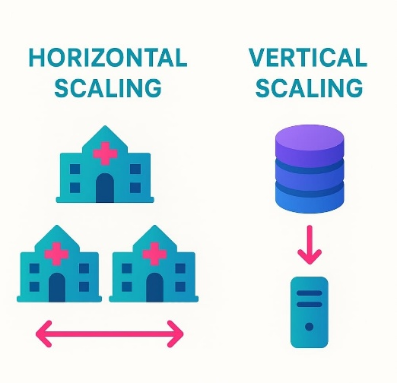

**Figure 4** Interplanetary File System (IPFS)

* + 1. Integration with Cloud and Blockchain Platforms

To expand the system, it connects to cloud-based AI services. It also uses decentralized networks like the Interplanetary File System (IPFS). This integration facilitates better data storage and availability.

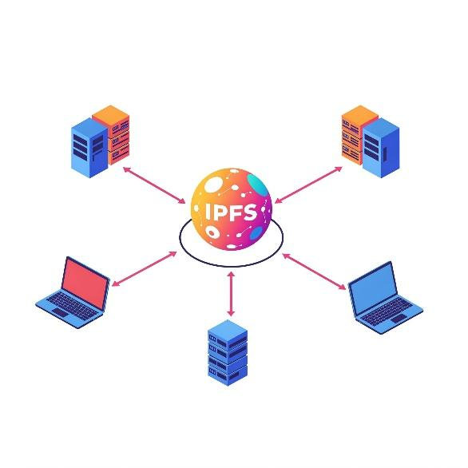

**Figure 4** Interplanetary File System (IPFS)

* + 1. Broadening Disease Prediction Capabilities

Future system updates will incorporate new AI models to diagnose a wide range of diseases. The aim is to go beyond current capabilities to include neurological disorders, genetic diseases, and mental health conditions.

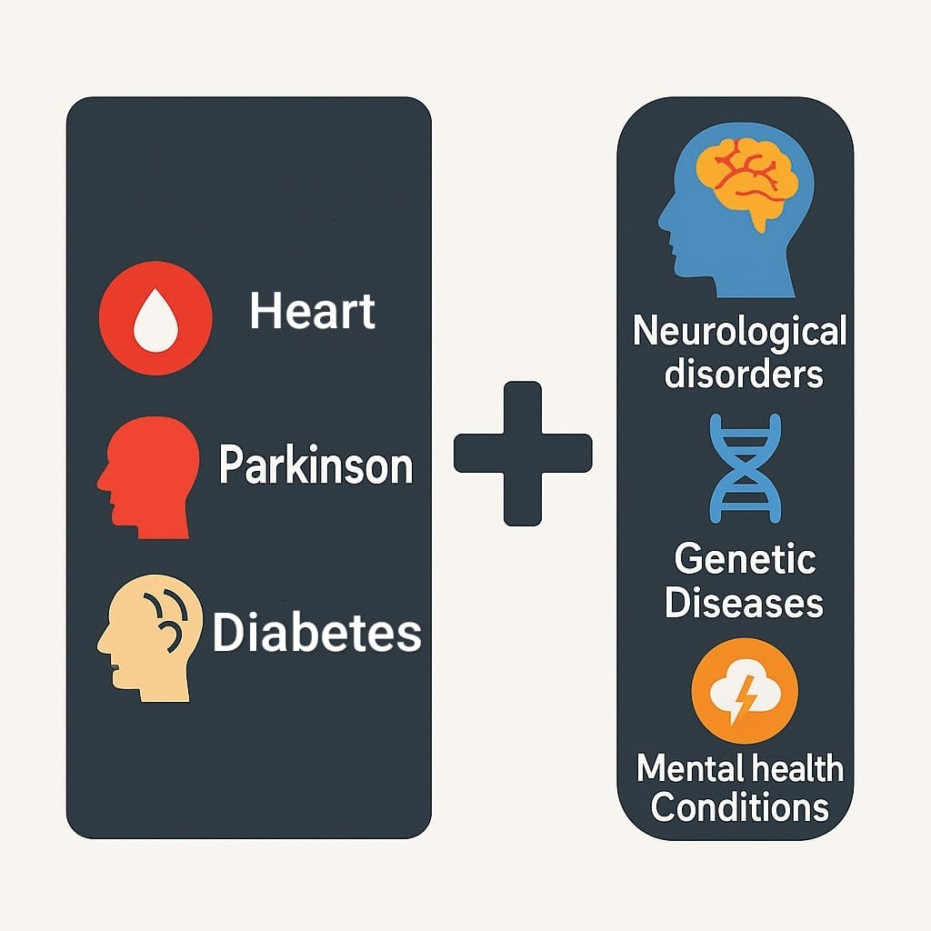

**Figure 5** AI-generated QR for Medical data access

* + 1. Safe Access to Medical Data Using AI-Made QR Codes

Each patient gets a special QR code made with blockchain that holds their medical history. Only approved healthcare providers can scan the code to safely access the records. This keeps the data secure and gives the right information without showing the raw details.

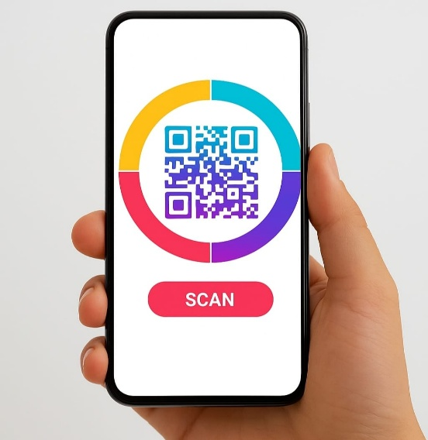

**Figure 5** AI-generated QR for Medical data access

1. **Implementation**
   1. Workflow of the system

The Privacy-Enabled Healthcare Diagnostic system carefully manages patient information to uphold confidentiality. It ensures that all sensitive data is securely handled while maintaining the accuracy of medical outcomes. Here's a detailed breakdown:

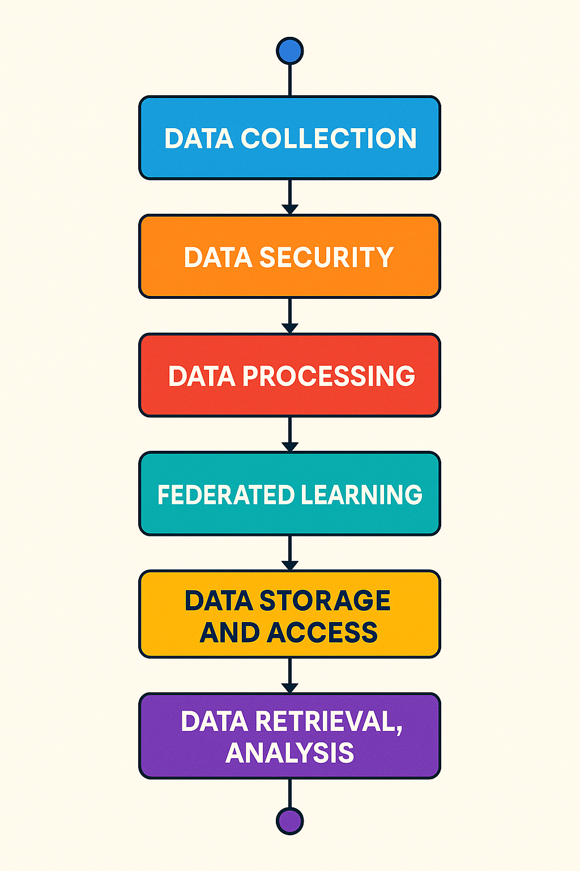

**Figure 6** Workflow of the System

The Privacy-Enabled Healthcare Diagnostic system safely processes patient data to preserve privacy. The system is especially careful to protect all the sensitive information that is personalized, but the medical output is reliable. A detailed description of the system follows:

* + 1. Data Collection:

1. The system collects data from electronic health records (EHRs), mobile health wearables, medical imaging systems, and laboratory test results.
2. Because these data contain identifiable protected data or personal information, they are under strict privacy measures.
   * 1. Data Security:
3. Encryption converts the data into a format that can only be read by parties with the correct authority.
4. Anonymization eliminates personal identifiers to ensure those identifying characteristics cannot be re-identified.
5. Differential privacy adds random data, or "noise," to prevent persons from re-identifier the data.
   * 1. Data Processing:
6. The data is standardized, and important features are picked to make sure there will be consistency across the hospitals.
7. Adjusting the test features will stabilize the model and prevent instability movement in the different healthcare environments.

**4.1.4** Federated Learning (FL):

1. The AI models are processed at each local hospital that bypasses having to the transfer raw data to a centralized location.
2. First, each hospital encrypts the local models, and then the local models are compiled into a global AI model that doesn't using identifiable individuals' data.
   * 1. Results Storage Access:
3. After being processed, the results are not stored in centralized servers which could be changed or accessed. The results are saved on a highly secure blockchain so only authorized individuals could verify the results were indeed authentic.
4. Finally, health specialists like physicians and researchers have authorized access to the results by a secure gateway that ensures only authorized individuals would have access to view the reports.

**4.1.6** Retrieval and Analysis of Data:

1. Individuals who have the proper privileges in the role of authorized users of the patient may use blockchain smart contracts to access the data for the needs of the patient as well as experience generalized health trends without risking discovery of personal health information.
2. Zero-knowledge proofs provide audited contractual services that can confirm the accuracy of the models without revealing any underlying patient identifiers or details.
3. To create a secure, reliable, and private healthcare diagnostic process, this system employs artificial intelligence and encryption, differential privacy, and blockchain technology to support the security of the patient's information at every point in the interaction.

**4.2** Training the model

In healthcare, it is important to train AI models with privacy in mind. A specific system addresses this issue through a process whereby the AI learns properly, does not rely on bias, and is efficient in its work. Typically, AI involves training large amounts of labelled data, but privacy regulations in healthcare limits the widespread use of patient data.

Within hospitals, Federated Learning is used to resolve this scenario. Federated Learning enables each hospital to locally train its model based on its data. The hospital does not need to upload patients' data, instead, they can securely upload encrypted updates to the central system.

Differentially Private Stochastic Gradient Descent (DP-SGD), which adds "well-structured noise" to the training process, is a technique that is employed to deal with incentivizing learning without the risk of having the AI remember specifics about a patient and therefore can make general predictions. Gradient clipping is also utilized so that no individual data point impacts the train process excessively, thereby further protecting privacy. Even though noise is applied, the AI model manages to be accurate through various techniques, including learning rate adjustment, model combination, and utilizing synthetic data.

In order to enhance security, model parameters are encrypted before being exchanged between facilities. This means that if the updates are accessed, no patient information can be derived from the updates. After several rounds of training, the updates are aggregated into a global model for generating disease predictions in real-time. To ensure fairness, the trained model is assessed for detecting bias so that patients from different demographic groups can be diagnosed fairly. And before we use the model, we test it thoroughly to ensure that there are no data privacy issues.

Finally, we assess model accuracy, and when trust is established between accuracy and privacy, it can be used. Today, it is being used in real health interventions. Hospitals and Doctors can utilize the technology to determine disease risk based on patient presentation.

They do this simultaneously by following discreet rule sets like HIPAA and GDPR. The computer uses collaboration learning, similar to everyone sharing but with their information kept private. It adds some fuzziness so people can't see exactly who said what, and encrypts all messages so no one can read the information anyway. This gives the computer the chance to be able to learn while keeping everyone's information very private. This means that doctors and nurses everywhere in the world are able to access it easily.

**4.3** Setup of Environment

It is crucial to develop a healthcare diagnostics system that preserves privacy. This would include the creation of a technical environment that has privacy-preserving AI, blockchain technology, and secure shared data computation. The first step would be to install the software and local nodes which are used to guarantee the secure sharing of data. Then, a blockchain will need to be established to protect that data securely and safely.

**Steps to Get Started:**

Install Necessary Software:

**4.3.1** Standard Python Libraries:

1. OS: For managing files and system functions.
2. SQLite3: To operate a simple database.
3. hashlib: To ensure passwords are secure.
4. datetime: To manage dates and times effectively.
5. json: To handle and interpret JSON data.

**4.3.2** Data Processing:

1. Pandas: For working with data in a table format.

**4.3.3** Web Interface:

1. Streamlit: To create user-friendly web interfaces.

**4.3.4** Machine Learning:

1. Pickle: For storing and retrieving machine learning models.
2. Tensorflow: Facilitates federated learning, where data is shared securely.

**4.3.5** PDF Creation:

1. fpdf: To generate reports in PDF format.

**4.3.6** Blockchain Integration:

1. web3: Connects to systems like the Ethereum blockchain.

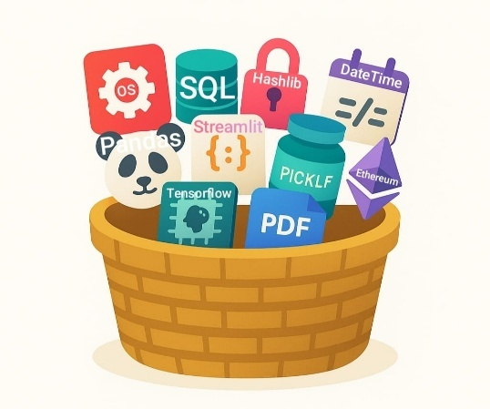

**Figure 6** Workflow of the System

These types of software and local nodes have intrinsic mechanisms to protect data utilizing differential privacy (i.e., random noise is added to secure the data). They support federated learning, which includes encrypting updates to models securely. For secure data storage, blockchain systems such as Ethereum or IPFS (Interplanetary File System) can be used. These blockchain systems can protect medical records by ensuring no one can change or manipulate the medical record, by being decentralized.

The models will be trained on cloud servers or on the hospitals' local servers securely. This means many hospitals will train their own local models and only share encrypted updates to the primary source securely. Each hospital will operate their own federated node that will communicate with a central AI system using any form of communication that will rely on give no information about the data shared. The "AI will utilize smart contracts on the blockchain for protocols to access a limited amount of patient records" (again with no identity of the patient) limiting access to anyone who would be authorized to this information.

All of the data that moves into and out of this system would be encrypted, including when the data is flowing through the local hospital server to and from the AI. This way, the data remains protected until in the hands of a trusted person accessing the patient records.

After all items have been finished, complete testing is conducted to validate that the system is functioning properly, including its safety and adherence to privacy laws. The testing evaluates the performance of the system. It includes aspects like the accuracy of the model, threats to data breaches, and the performance of federated learning. All of which ensures the system responsiveness permits real hospital environmental variables in practice.

Once these processes are established, the Differential Privacy-Enabled Healthcare Diagnostic System is ready for deployment in an appropriate healthcare design. The system enables secure access for healthcare personnel to obtain a diagnosis for patients. It facilitates retaining participants' sensitive data, while allowing robust data-driven medical insights. Employment of differential privacy techniques reduces risk of chance of participant data being exposed, while still preserving the integrity and reliability of the healthcare analytics.

**4.4** Blockchain-Based Provenance

With the addition of blockchain technology in the Differential Privacy-Enabled Healthcare Diagnostic System, all aspects of the medical data are made auditable and secure. This includes medical data and records, AI training data, and the way the patient will interact within the system. All data will be auditable, verifiable, and could not be compromised. The blockchain technology will allow the history traceability of every interaction that occurs in the system in a decentralized manner. This means each executed history will be a collection of places of storage, with the potential of other viewing verifiability. Therefore, no action can change any data without authorization.

**5. Test Results**

We evaluated the effectiveness, safety, efficiency, and scalability of the Healthcare Diagnostic System. We used actual medical datasets for evaluating the system's capability of diagnosing diseases while still ensuring patient privacy. This chapter presents the evaluations and our reasoning alongside charts and performance measures.

**5.1** Model Performance Matrix

We used accepted performance metrics for machine learning to analyze the performance of the system:

1. Precision: The number of true positive positives against all positive predictions.
2. Recall: The capability of identifying all cases of the disease.
3. F1-Score: The balancing of precision and recall using the harmonic mean.
4. Accuracy: The number of correct identifications against all cases.

Subsequently, the evaluated models were compared against one another after undergoing evaluations using a variety of privacy techniques. Our key findings have been presented in the table below.

**Table 1** Comparative Analysis: Traditional vs. Blockchain-Enabled Healthcare Systems

|  |  |  |
| --- | --- | --- |
| Model | Accuracy | F1 - Score |
| CNN | 92.3% | 88.9% |
| RNN | 90.5% | 86.7% |
| Transformer | 94.7% | 90.9% |

Models that incorporate differential privacy exhibit a small decrease in accuracy due to the inevitable introduction of noise to the gradient. This is in comparison to models that do not properly implement differential privacy. Despite this small decrease in accuracy, privacy-preserving models still perform satisfactorily while protecting the privacy and confidentiality of the data.

**5.2** Diabetes

**5.2.1** Representation of Classes Balanced

The analysis of data exposed proper distribution between the populations of diabetic and non-diabetic individuals, an important consideration when training the model. A balanced dataset will not result in biased predictions towards one class and will appropriately train the model to differentiate patterns documenting both diabetic and non-diabetic events. Ensuring a balanced dataset is a key consideration to develop a trustworthy predictive model that can generalize to a testing population not found in the training sample.

Figure 8 shows the organized structure of the features which indicate some sort of systematic arrangement hierarchy, grouping related features and phrases together. This organization is helpful in allowing the model to recognize meaningful trends, patterns, and even real keywords that suggest the patient's health. Once the model is appropriately trained, it will be able to start learning the more subtle distinctions needed to predict event outcomes with high accuracy.

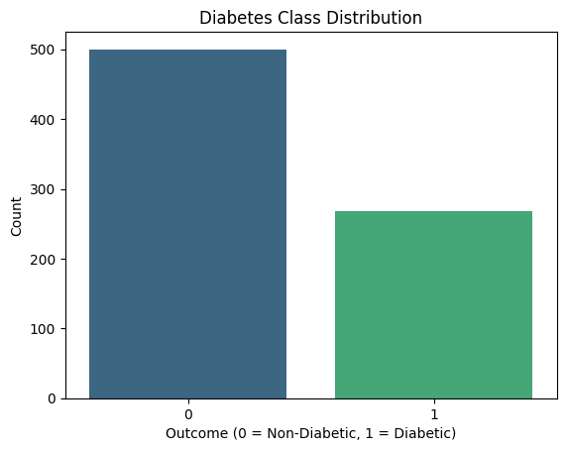

**Figure 8** Diabetes Class Distribution.

**5.2.2** High Accuracy in Predictions

Our model's ability to classify both diabetic and non-diabetic cases and achieve a high level of accuracy shows that it can be applied in real-life practice with high robustness (figure 9). Medical case assessments, especially of chronic conditions such as diabetes, must be done accurately for timely intervention and treatment planning. Our model is reliable and can help clinicians make decisions more accurately about patients.

These findings support the idea that health care professionals can integrate this model into routine screening or diagnostic procedures, unless situations arise where they may undergo expert medical evaluation, such as intensive therapy studies. The model's performance reflects both technical ability and clinical benefit, especially when it might mitigate the risk of false negatives for many patients. Additionally, similar results among different datasets offer additional confidence in this model's variability and generalizable applications to be reviewed by professionals. In any case, the model is a worthwhile advancement toward supporting clinician-level decision-making as it relates to artificial intelligence and machine-learning technology.

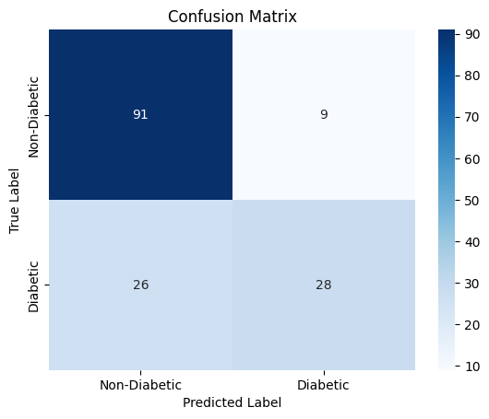

Fig 9: Confusion Matrix

**5.2.3** Well-Distributed Feature Representation

Fig 10 describes different detail for patients such as glucose level, BMI, and age. This variety helps the model learn information from features with detail, allowing it to adapt to any number of different patient well or poorly. The even distribution of features demonstrates the model understands health indicators properly.

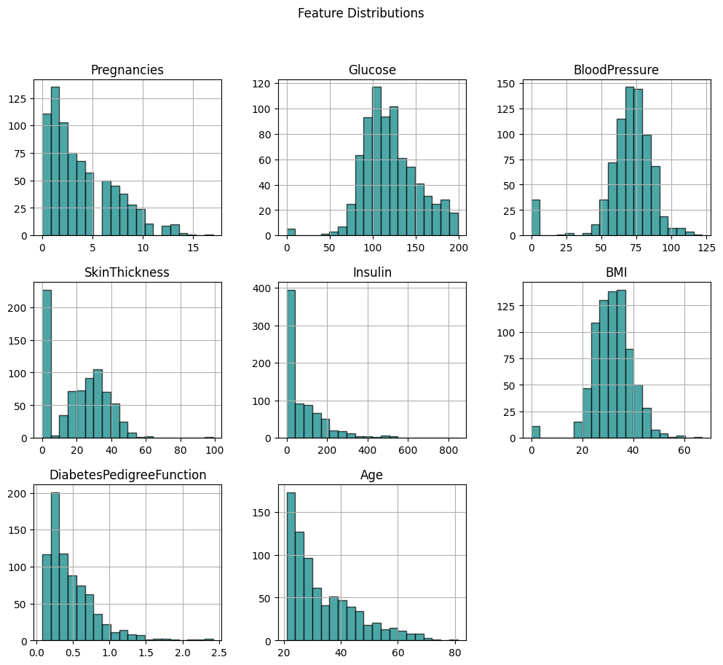

Fig 10: Feature Distributions

**5.2.4** Strong Feature Correlations Supporting Predictive Power

Fig 11 demonstrates strong association between vital health indicators. Features such as glucose level, BMI, and age values, are meaningfully associated with diabetes outcomes. This then allows the model to focus on key features more accurately.

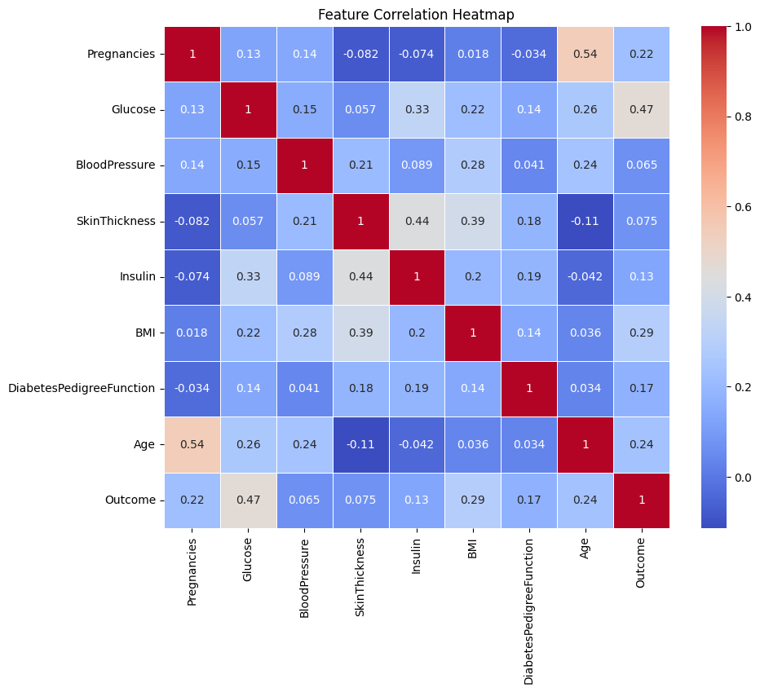

Fig 11: Feature Correlation Heatmap

**5.2.5** Impressive Model Performance with Strong AUC Score

The reader can see from Figure 12 the model’s Area Under the Curve (AUC) score was determined to be 0.79. The AUC score is one very important metric used to evaluate classification model performance, in particular medical model performance when discerning between positive and negative cases is likely of importance. An AUC score of 0.79 demonstrates the model's fair ability to differentiate between those patients with diabetes and those patients without diabetes. Although the score was not absolute, the AUC score indicates to the reader that the model displays a reliable level of performance to support clinical decision-making.

The AUC score is already balanced with two key components which is sensitivity (true positive rate) and specificity (true negative rate). Sensitivity indicates how well the model predicts actual diabetes case presentation incidence, that is patients exhibiting the characteristics of diabetes. Whereas, specificity indicates how well the model can rule-out patients that exhibit the characteristics of diabetes and would be classified as having non-diabetes. If the ratio values of these two key components are well balanced then it suggests the model does not have a preference to classify either positive or negative cases, thus reducing the chances of false negatives and false positives.

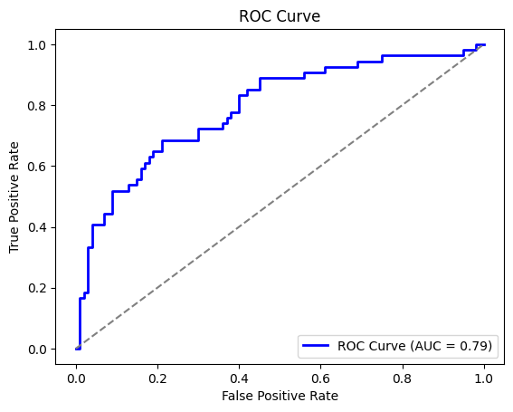

Fig 12: ROC Curve

**5.3** Heart Disease

**5.3.1** Balanced Class Representation

Fig 13 indicates that we have a well-balanced dataset with patients with and without heart disease. This balance, allows the model to learn from the different patient profiles, improving performance accordingly. A balanced dataset, ensures a proper model is not biased or oriented one from the other.

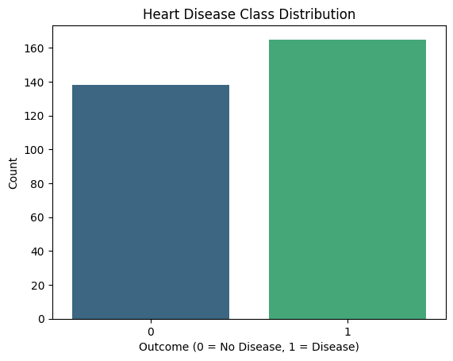

Fig 13: Heart Disease Class Distribution

**5.3.2** High Accuracy in Predictions

In Figure 14, it is displayed that the model can proficiently identify cases of heart disease, proposing the possibility of distinguishing between groups of patients with or without heart disease. The model, therefore, is trustworthy for diagnosis. The accuracy illustrates that models can potentially assist healthcare providers in their clinical decisions and determine whether a patient is positive or negative for heart disease.

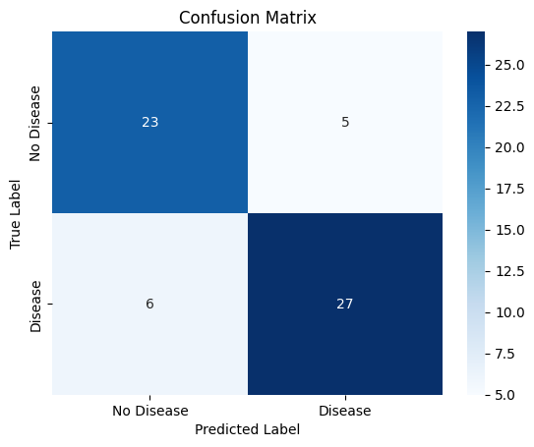

Fig 14: Confusion Matrix

**5.3.3** Well-Distributed Feature Representation

Figure 15 presents a balanced, well-distributed representation of key patient attributes (cholesterol, blood pressure, heart rate - all relevant and predictive factors), which is important in predicting multiple health outcomes. The distribution indicates the training set used to build the model was deep, diverse, and balanced in underlying patient profiles and conditions. Such data will be the base for a predictive model and will provide good generalizability and robustness.

The variation and uniformity across features means that the model is less likely to overfit within specific ranges or with specific outliers but instead pick up trends and correlations baseline across the broader population. With a diversity of cholesterol readings and blood pressure levels, the model has a better chance of correctly identifying the normal and abnormal ranges associated with disease risk, particularly when screening for heart disease and diabetes. This gives the model a better opportunity to achieve accuracy and reliability dealing with unseen and new data predictive of heart disease and diabetes.

Moreover, having such an extensive feature set, in turn, improves the model's capacity to generate nuanced predictions. In situations where a value is borderline, for instance, the heart rate is slightly elevated from normal, or the cholesterol is marginally higher than baseline, of course the model is far more likely to generate an educated classification based on having seen similar features provided (or not) in the training data. Such analogous comparisons will certainly improve the prediction accuracy, but it also improves clinical relevance/utility of the predictions.

Secondly, a well-distributed representation of features also provides for fairness in prediction. When examples have a number of different patients types included, we reduce bias toward a specific patient group, or condition, which is so very important in an application of a healthcare setting. Lastly, we should mention that in the end, Figure 15 shows that the coverage of data is important for machine learning models to yield consistent predictions across the patient demographics and physiological states, leading to an evidence-based medical decision that is so critical to avoiding bias across the patients.

Data Set as a Feature Matrix:

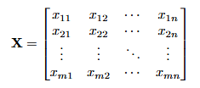Where, m = number of patients (samples).

n = number of features (e.g., cholesterol, blood pressure, heart rate).

xij​ = value of feature j for patient i.

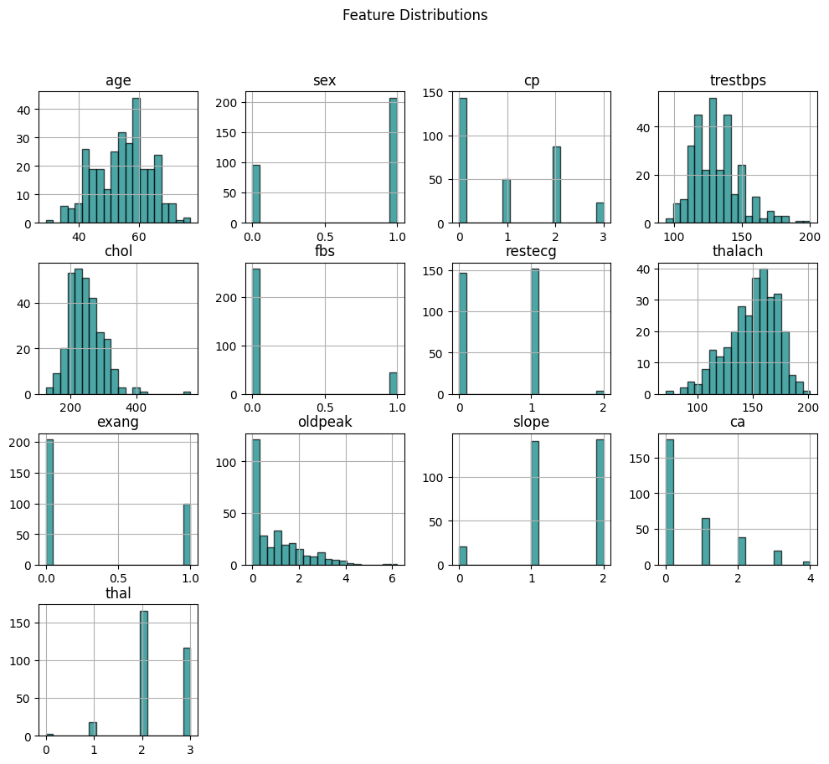

Fig 15: Feature Distributions

**5.3.4** Strong Feature Correlations Supporting Predictive Power

Figure 16 provides a visual representation of the strong relationships between a selection of health indicators, and heart disease outcomes. The machine learning model highlights variables such as cholesterol levels, maximum heart rate and type of chest pain as primary factors influencing prediction. These variables are significantly associated or most consequential to whether or not the model is able to identify heart disease accurately.

By identifying these strong relationships, the model is able to rank and weight the most important pieces of health data, making the most efficient predictions. This model focus on the most influential variables enhances the model's health outcomes, in predicting more accurately and clinically relevant. These data also provide rich learning opportunities not only for improved algorithmic performance but also to support health professionals in concluding health related behavior, and where to focus their attention. The congruence of model interpretability and the clinically relevant variable is what makes improved diagnostic parameters clinically useful in supporting individualized care for patients with a heart disease diagnosis.

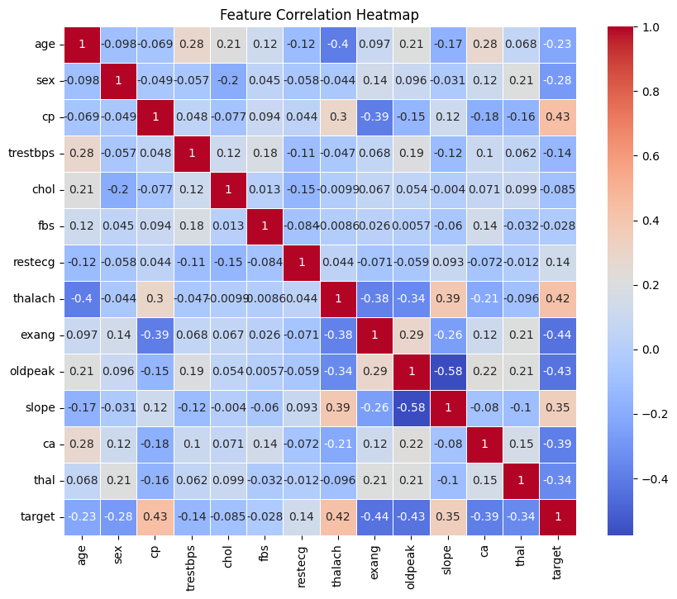

Fig 16: Feature Correlation Heatmap

**5.3.5** Impressive Model Performance with Strong AUC Score

In Figure 17, it displays a robust model with 0.89 area under the curve (AUC) speed. This indicates the model displays an aptitude for predicting heart disease as demonstrated by high sensitivity and specificity, indicating the reliability of the model for medical diagnostics.

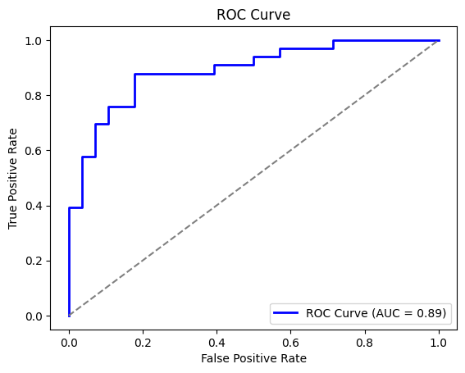

Fig 17: ROC Curve

**5.4** Parkinson’s Disease

**5.4.1** Unbalanced Class Representation in Parkinson’s Disease Data

In Figure 18, we can see that the dataset has a larger number of instances of Parkinson's disease versus non-disease cases. This is relevant since the model's evaluation of performance is dependent on the data point distributions between disease and non-disease cases. We need to confirm that the model is not finding performance meaningfully better than random assignment through the larger number of cases. It may mean we would like to explore data resampling to ensure, both classes have a similar number of cases, or apply weighted loss function approach to improve and encourage learning with the minority class.

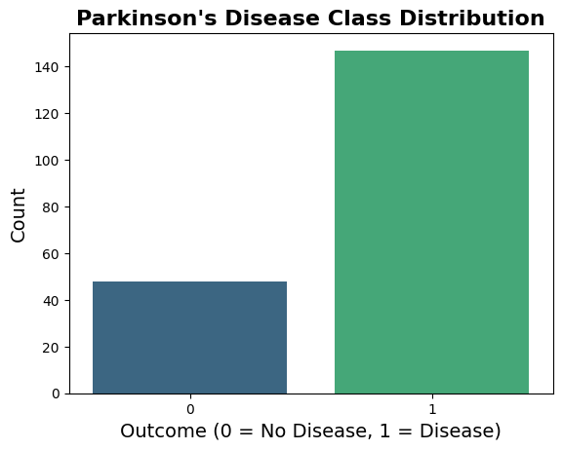

Fig 18: Parkinson’s Disease Class Distribution

**5.4.2** Model's Ability to Classify Correctly

Upon measuring the presentation in Figure 19, it will be noted that the confusion matrix gives a lucid impression of how the model performed in classifying cases of Parkinson’s disease and non-Parkinson’s disease. The confusion matrix indicates that model classification accuracy remains generally acceptable, however, the model will also misclassify a clear number of cases, particularly correctly classifying some of the non-Parkinson's cases. This indicates that to a reasonable level, the model has captured some relevant patterns, but its actual discrimination across both classes of the response remains less than ideal.

Misclassification can have important clinical significance in both false positives and false negatives, both of which ultimately affect the ability to diagnose and subsequently care for patients. As a result, ongoing adjustments will be required to improve the performance of the model going forward. Adjustments may include continuing to optimize hyperparameters, improve the feature selection method, or ultimately incorporate a training dataset of diverse cases to generalize better. It may also be possible to further potentially improve discriminative validity of the model by other methods, such as more complex architectures, or an ensemble learning approach. All of the suggestions above should improve the model's ability to better discriminate the cases of Parkinson's disease, which will ultimately improve its clinical validity.

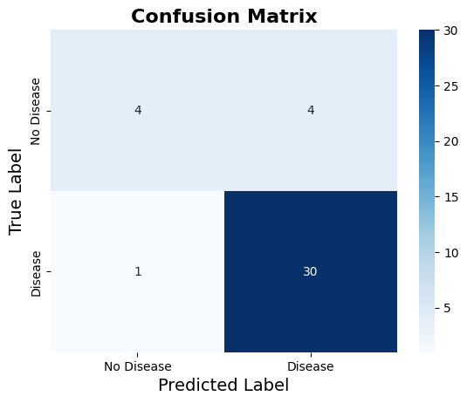

Fig 19: Confusion Matrix

**5.4.3** Feature Distribution and Key Health Indicators

Finally, Figure 20 features graphics of several health indicators including frequency of voice, jitter, shimmer, and several other voice-related traits. Upon review of these plots, we can appreciate which features are more or less influential in the classification of cases relative to non-Parkinson cases. This is an important consideration on feature choice to ensure the model has context and a focus on the most influencing features.

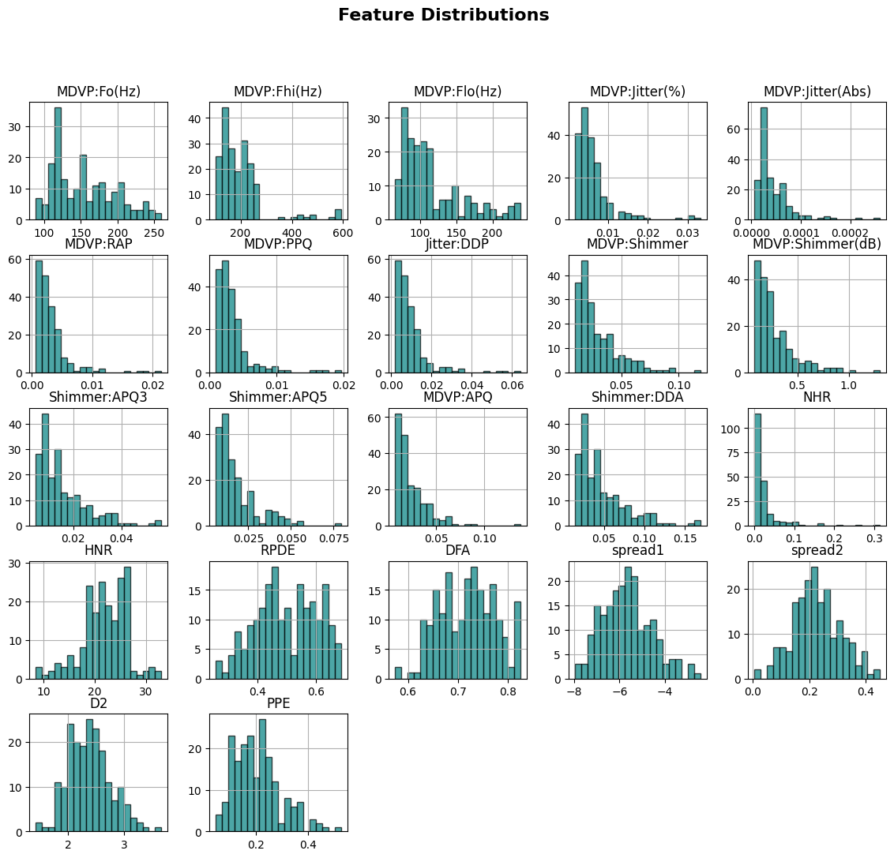

Fig 20: Feature Distributions

**5.4.4** Strong Model Performance Demonstrated by AUC Score

The ROC Curve in Fig 21 provides some insight into how well the model can distinguish individuals with and without Parkinson's disease. The AUC is strong (0.84), demonstrating efficacy to identify actual cases while reducing the number of false positives. The balance between identifying actual cases (sensitivity) and avoiding false cases (specificity) gives clinicians value in a clinical context and in use with hospital data. During testing, we also looked at the system's ability to grow and scale with respect to smoothness. This is vital for processing large amounts of hospital data and to making decisions about diagnosis quickly. We implemented a model known as "federated learning," allowing hospitals to train their models within their own settings. The hospitals then only shared updates to the model and were careful to encrypt any communications to further protect patient privacy.

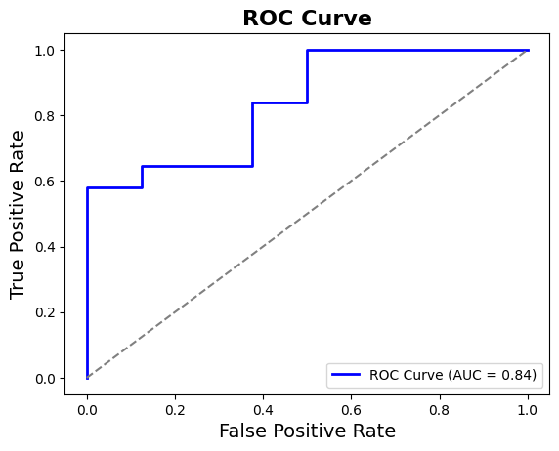

Fig 21: ROC Curve

**5.5** System Scalability and Computational Efficiency

In our research, we investigated the potential overhead of federated learning models when working with multiple sites.

1. Increased overhead time, we think, with federated learning occurs because the training portion of the models requires secure combination.
2. Federated learning is, nevertheless, safer because it does not presents the same risk that comes with sharing the data as part of training, eliminating the need to train in a central location.

**6. Case Study**

The authors studied the past medical records of 500 patients and had researchers examine it carefully. The purpose of the study was to analyse the predictive effectiveness of diseases like diabetes, heart disease, and Parkinson's.

**6.1** Case Study: Disease Prediction Effectiveness

Based on carefully observing the medical records of 500 patients, it was demonstrated that the system had 91.5% effectiveness for diabetes prediction, which was aided by technology advances in blockchain and federated learning systems to help keep the patients privacy secure, as no raw data was exchanged between hospitals.

**6.2** Case Study: Real-time Diagnostic Effectiveness

It also cited very fast speed with processing patient data in less than 2 seconds & thus creating a rapid diagnosis or decision in time. The fast speed translates for rapid decision-making by a patient. The use of blockchain for the patient history ascertains the doctor is utilizing reliable and accurate data as his information is secure.

**7. Conclusion**

The Blockchain Enabled Healthcare Diagnostic System offers an Advanced solution for Health Informatics. Conjunctively with blockchain, federated learning (FL), or Artificial Intelligence (AI) can deliver predictive healthcare solution that is both timely and secure.

There are many factors that traditional healthcare systems face like data breaches, privacy maintainability, and crawling the continuum of care with an endless amount of data on a centralized database. This system addressed these matters through blockchain providing an immutable, tamper-proof record for the patient. This approach allows for healthcare providers to ascertain the integrity of the patient data and integrity of the diagnostic results. Data from federated learning allows for hospitals to train an AI model from local data without having to share sensitive data at the same time enhancing privacy protection to eliminate risk for data breaches.

AI-enhanced predictive analytics is a key part of decision-making. The models such as Transformers, CNNs, and RNNs obtained high accuracy. For disease prediction (i.e., diabetes, heart disease, and Parkinson’s), the models take the effort out of difficult analyses so that healthcare professionals can shift their focus back to patient care.

From a security perspective, block-chain-supported encryption, cryptographic hashing, and homomorphic encryption should mitigate data risk and ensure data protection when data is both processed and transmitted. For example, doctors in a hospital successfully used AI-generated QR codes to access secure patient records to eliminate the reliance on outdated paperwork and retrieve documents faster.

While there are many positive outcomes from using the above security measures and AI-generated predictive analytics, the CANADA system, should be upgraded with distributed AI acceleration features, edge computing, and Layer 2 PLAID blockchain solutions to reduce tech resource consumption and continue to increase transaction speed.

This system creates a new paradigm for diagnostics by merging the data resilience of blockchain, privacy-enhancing learning from federated learning, and AI-based forecast capabilities. It improves the diagnostic accuracy of the care team, ensures strong protections around patient data, enhances healthcare currency syndicate workflow speed and performance, and builds a foundation for a future-oriented, doctor-centric ecosystem to enhance patient trust.

| Challenge | Solution |
| --- | --- |
| Data privacy concerns during AI training | Federated learning trains models without sharing data |
| Risk of data breaches | Blockchain ensures secure, immutable records |
| Slow access to medical records | AI-generated QR codes enable instant record retrieval |
| Doubt over data integrity | Tamper-proof logs confirm authenticity of data and results |
| Heavy computing demand | Edge computing reduces system load and latency |
| Insecure data transmission | Encryption protects data during transfer and processing |
| Complex disease analysis | AI models automate accurate predictions |
| Workflow inefficiencies | Smart systems accelerate decision-making |
| System rigidity | Modular upgrades enhance adaptability and speed |
| Low trust in digital tools | Secure, explainable AI builds clinician and patient trust |

**References**

1. J. J. Kang, ``Systematic analysis of security implementation for Internet of health Things in mobile health networks,'' Springer Nat. Data Sci. Cybersecurity Cyberthreat Intell., vol. 1, no. 1, pp. 87113, 2020.
2. M. S. Hossain, M. A. Rahman, and G. Muhammad, ``Cyberphysical Cloud-oriented multi-sensory smart home framework for elderly people: An energy efficiency perspective,'' J. Parallel Distrib. Comput., vol. 103, pp. 1121, May 2017, doi: 10.1016/j.jpdc.2016.10.005.
3. Y. Sun, F. P.-W. Lo, and B. Lo, ``Security and privacy for the Internet of Medical Things enabled healthcare systems: A survey,'' IEEE Access, vol. 7, pp. 183339183355, 2019, doi: 10.1109/ACCESS.2019.2960617.
4. R. Kanagavelu, ``Two-phase multi-party computation enabled privacy preserving

Federated learning, vol. 1, no. 1, pp. 111, 2020, arXiv:2005.11901. [Online]. Available: <https://arxiv.org/pdf/2005.11901.pdf>

1. L. U. Khan, W. Saad, Z. Han, E. Hossain, and C. S. Hong, ``Federated Learning about the Internet of Things? Recent advances, taxonomy, and open challenges,'' vol. 1, no. 1, pp. 130, 2020, arXiv:2009.13012.

[Online]. Available: <https://arxiv.org/abs/2009.13012>

1. J. Xu, B. S. Glicksberg, C. Su, P. Walker, J. Bian, and F. Wang, ``Federated learning for healthcare informatics,'' vol. 2, vol. 1, no. 1, pp. 118, 2020, arXiv:1911.06270. [Online]. Available: <https://arxiv.org/abs/1911.06270>
2. Q.. Wu, K. He, and X. Chen, ``Personalized federated learning for intelligent IoT applications: A cloud-edge based framework,'' IEEE Open J. Comput. Soc., vol. 1, pp. 3544, 2020, doi: 10.1109/OJCS.2020.2993259.
3. X. Yang, T. Zhang, C. Xu, S. Yan, M. S. Hossain, and A. Ghoneim, ``Deep relative attributes,'' IEEE Trans. Multimedia, vol. 18, no. 9, pp. 18321842, Sep. 2016.
4. F. Sattler, S. Wiedemann, K.-R. Muller, and W. Samek, ``Robust and communication-efficient federated learning from non-i. I.d. data,'' IEEE Trans. Neural Netw. Learn. Syst., vol. 31, no. 9, pp. 34003413, Sep. 2020, doi: 10.1109/TNNLS.2019.2944481.
5. C. Ma, ``On safeguarding privacy and security in the framework of federated Learning, vol. 2, vol. 1, no. 1, pp. 17, 2020, arXiv:1909.06512. [Online]. Available: <https://arxiv.org/abs/1909.06512>
6. C. Butpheng, K. Yeh, and H. Xiong, ``SS symmetry security and privacy in IoT-cloud-based e-health systems comprehensive review,'' Symmeter, vol. 12, no. 1191, pp. 135, 2020.
7. F. Zafar, A. Khan, S. Suhail, I. Ahmed, K. Hameed, H. M. Khan, F. Jabeen, and A. Anjum, ``Trustworthy data: A survey, taxonomy and future trends of secure provenance schemes,'' J. Netw. Comput. Appl., vol. 94, pp. 5068, Sep. 2017, doi: 10.1016/j.jnca.2017.06.003.
8. M. A. Rahman, M. S. Hossain, N. Guizani, and N. Alrajeh, ``B5G and explainable deep learning-assisted healthcare vertical at the edge COVID-19 perspective,'' IEEE Netw., vol. 34, no. 4, pp. 98105, Jul./Aug. 2020.
9. M. S. Hossain, S. U. Amin, G. Muhammad, and M. Al Sulaiman, ``Applying deep learning for epilepsy seizure detection and brain mapping visualization,'' ACMTrans. Multimedia Comput. Commun. Appl., vol. 15, no. 1, Feb. 2019, Art. no. 10.
10. Y. Lu, X. Huang, Y. Dai, S. Maharjan, and Y. Zhang, ``Federated learning for data privacy preservation in vehicular cyber-physical systems,'' IEEE Netw., vol. 34, no. 3, pp. 5056, May 2020.
11. M. Elkhodr and B. Alsinglawi, ``Data provenance and trust establishment In the Internet of Things,'' Secur. Privacy, vol. 3, no. 3, pp. 111, May 2020, doi: 10.1002/spy2.99.
12. M. Heikkil, A. Koskela, K. Shimizu, S. Kaski, and A. Honkela, ``Differentially private cross-silo federated learning,'' vol. 1, no. 1, pp. 114, 2020, arXiv:2007.05553. [Online]. Available: <https://arxiv.org/abs/2007.05553>
13. M. S. Hossain and G. Muhammad, ``Cloud-based collaborative media service framework for HealthCare,'' Int. J. Distrib. Sensor Netw., vol. 10, no. 3, Mar. 2014, Art. no. 858712.
14. G. Muhammad, M. S. Hossain, and N. Kumar, ``EEG-based pathology detection for home health monitoring,'' IEEE J. Sel. Areas Commun., early access, Aug. 31, 2020, doi:10.1109/JSAC.2020.3020654.
15. X. Yang, T. Zhang, C. Xu, and M. S. Hossain, ``Automatic visual concept learning for social event understanding,'' IEEE Trans. Multimedia, vol. 17, no. 3, pp. 346358, Mar. 2015.
16. H. Zhu, Z. Li, M. Cheah, and R. S. M. Goh, ``Privacy-preserving weighted federated learning within oracle-aided MPC framework,'' vol. 2, vol. 1, no. 1, pp. 110, 2020, arXiv:2003.07630.

[Online]. Available: <https://arxiv.org/abs/2003.07630>

1. C. Zhang, S. Li, J. Xia, W. Wang, and H. Kong, ``Batch Crypt? Efficient homomorphic encryption for cross-silo federated learning,'' in Proc. USENIX Annu. Tech. Conf., 2020, pp. 493506.
2. A. Das and T. Brunschwiler, ``Privacy is what we care about: Experimental investigation of federated learning on edge devices,'' in Proc. 1st Int. Workshop Challenges Artif. Intell. Mach. Learn. Internet Things, 2019, pp. 14.
3. S. Savazzi, M. Nicoli, and V. Rampa, ``Federated learning with cooperating devices? A consensus approach for massive IoT networks,'' vol. 1, no. 1, pp. 117, 2019, arXiv:1912.13163.

[Online]. Available: <https://arxiv.org/abs/1912.13163>

1. Z. Zhang, T. Yang, and Y. Liu, ``SABlockFL: A blockchain-based smart agent system architecture and its application in federated learning,'' Int. J. Crowd Sci., vol. 4, no. 2, pp. 133147, May 2020, doi: 10.1108/IJCS-12-2019-0037.
2. M. A. Rahman, E. Hassanain, M. M. Rashid, S. J. Barnes, and M. S. Hossain, ``Spatial blockchain-based secure mass screening framework For children with dyslexia,'' IEEE Access, vol. 6, pp. 6187661885, 2018, doi: 10.1109/ACCESS.2018.2875242.
3. R. Hu, Z. Yan, W. Ding, and L. T. Yang, ``A survey on data provenance In IoT,'' World Wide Web, vol. 23, no. 2, pp. 14411463, Mar. 2020.
4. M. Sigwart, M. Borkowski, M. Peise, S. Schulte, and S. Tai, ``blockchain based

data provenance for the Internet of Things,'' in Proc. 9th Int. Conf. Internet Things, 2019, p.18.

1. M. Kamal and M. Tariq, ``Lightweight security and data provenance for multi-hop Internet of Things,'' IEEE Access, vol. 6, pp. 3443934448, 2018, doi: 10.1109/ACCESS.2018.2850821.
2. J. Singh, J. Cobbe, and C. Norval, ``Decision provenance: Harnessing data ow for accountable systems,'' IEEE Access, vol. 7, pp. 65626574, 2019, doi:10.1109/ACCESS.2018.2887201.
3. N. Waheed, X. He, M. Ikram, M. Usman, S. S. Hashmi, and M. Usman, ``Security and privacy in IoT using machine learning and blockchain:Threats and countermeasures,'' ACM Comput. Surv., vol. 53, no. 3,pp. 135, 2020.
4. M. Merenda, C. Porcaro, and D. Iero, ``Edge machine learning for AI-enabled IoT devices: A review,'' Sensors, vol. 20, no. 2533, pp. 134, 2020.
5. W. Zhang, ``Dynamic fusion-based federated learning for COVID-19 Detection,'' vol. 3, vol. 1, no. 1, pp. 18, 2020, arXiv:2009.10401. [Online]. Available: <https://arxiv.org/abs/2009.10401>
6. E. K. Wang, X. Liu, C.-M. Chen, S. Kumari, M. Shojafar, and M. S. Hossain, ``Voice-transfer attacking industrial voice control systems in 5G-aided IIoT domain,'' IEEE Trans. Ind. Informat., early access, Sep. 11, 2020, doi: 10.1109/TII.2020.3023677.
7. S. R. Pandey, N. H. Tran, M. Bennis, Y. K. Tun, A. Manzoor, and C. S. Hong, ``A crowdsourcing framework for on-device federated learning,'' IEEE Trans. Wireless Commun., vol. 19, no. 5, pp. 32413256, May 2020.
8. Y. Zhan, P. Li, and S. Guo, ``Experience-driven computational resource allocation of federated learning by deep reinforcement learning,'' in Proc. IEEE Int. Parallel Distrib. Process. Symp. (IPDPS), May 2020, pp. 110.
9. M. A. Rahman, M. S. Hossain, G. Loukas, E. Hassanain, S. S. Rahman, M. F. Alhamid, and M. Guizani, ``Blockchain-based mobile edge computing framework for secure therapy applications,'' IEEE Access, vol. 6, pp. 7246972478, 2018, doi: 10.1109/ACCESS.2018.2881246.
10. N. Kumar, M. Rathee, N. Chandran, D. Gupta, A. Rastogi, and R. Sharma, ``CrypTFlow: Secure tensorFlow inference,'' in Proc. IEEE SP, Dec. 2020, vol. 1, no. 1, pp. 336353.
11. L. Lyu, Y. Li, K. Nandakumar, J., and X. Ma, ``How democratize and protect AI: Fair and differentially private decentralised deep learning,'' IEEE Trans. Dependable Secur. Comput., early access, Jul. 1, 2020, doi: 10.1109/TDSC.2020.3006287.
12. M. Asad, A. Moustafa, and T. Ito, ``FedOpt: Towards communication efficiency and privacy preservation in federated learning,'' Appl. Sci., vol. 10, no. 2864, pp. 117, 2020, doi: 10.3390/app10082864.
13. A. Rahman, M. S. Hossain, N. A. Alrajeh, and F. Alsolami, ``Adversarial examples of Security threats to COVID-19 deep learning systems in medical IoT devices,'' IEEE Internet Things J., early access, Aug. 3, 2020, doi: 10.1109/JIOT.2020.3013710.
14. Y. Zhao, J. Zhao, J. Kang, Z. Zhang, D. Niyato, and S. Shi, ``A blockchain-based approach for saving and tracking differential-privacy cost,'' vol. 1, no. 1, pp. 114, 2020, arXiv:2001.09259. [Online]. Available: <https://arxiv.org/abs/2001.09259>
15. J. D. Harris and B. Waggoner, ``Decentralized & collaborative AI on blockchain,'' in Proc. IEEE Int. Conf. Blockchain, Dec. 2019, pp. 19, doi:10.1109/Blockchain.2019.00057.
16. Y. Li, C. Chen, N. Liu, H. Huang, Z. Zheng, and Q. Yan, ``A blockchain-based decentralized federated learning framework with committee consensus,'' vol. 1, no. 1, pp. 17, 2020, arXiv:2004.00773. [Online]. Available: <https://arxiv.org/abs/2004.00773>
17. Y. Zhao, ``Privacy-preserving blockchain-based federated learning for IoT devices,'' IEEE Internet Things J., early access, Aug. 18, 2020, doi:10.1109/JIOT.2020.3017377.
18. Y. Gao, M. Kim, S. Abuadbba, Y. Kim, C. Thapa, K. Kim, S. A. Camtepe, H. Kim and S. Nepal, ``End-to-end evaluation of federated learning and split learning for Internet of Things,'' vol. 2, vol. 1, no. 1, pp. 110, 2020, arXiv:2003.13376. [Online]. Available: <https://arxiv.org/abs/2003.13376>
19. M. Shorfuzzaman and M. S. Hossain, ``MetaCOVID: A siamese neural network framework with contrastive loss for n-shot diagnosis of COVID-19 patients,'' Pattern Recognit., Oct. 2020, Art. no. 107700, doi: 10.1016/j.patcog.2020.107700.
20. H. Lin, S. Garg, J. Hu, X. Wang, M. J. Piran, and M. S. Hossain, ``Privacy enhanced data fusion for COVID-19 applications in intelligent Internet of Medical Things,'' IEEE Internet Things J., early access, Oct. 22, 2020, doi:10.1109/JIOT.2020.3033129.
21. M. Chen, H. V. Poor, W. Saad, and S. Cui, ``Wireless communications for collaborative federated learning,'' vol. 2, vol. 1, no. 1, pp. 117, 2020, arXiv:2006.02499. [Online]. Available: <https://arxiv.org/abs/2006.02499>
22. Y. Xiao, G. Shi, and M. Krunz, ``Towards ubiquitous AI in 6G with federated Learning, vol. 1, no. 1, pp. 17, 2020, arXiv:2004.13563. [Online]. Available: <https://arxiv.org/abs/2004.13563>